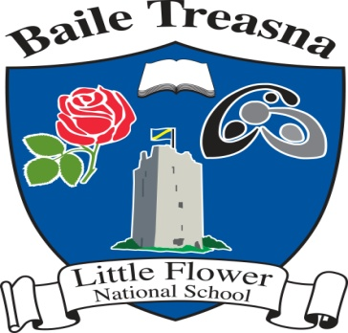
Ballytarsna N.S.
ANNUAL ADMISSION NOTICE
In respect of admissions to the 2026/2027 school year
Admission Policy and Application Form
A copy of the school’s Admission Policy and the Application form for Admission for the 2026/2027 school year is available as follows:
On request: By emailing littleflowerns@gmail.com or phoning the school office at 0504 41323.

PART 1 – Admissions to the 2026/2027 school year
Application and Decision Dates for admission to 2026/2027 school year
The following are the dates applicable for admission to Junior Infants
The school will commence accepting applications for admission on | 26/01/2026
The school shall cease accepting applications for admission on  (There must be a minimum period of 3 weeks between this date and the commencement date for accepting applications for admission) | 23/02/2026
The date by which applicants will be notified of the decision on their application is  (This date must be within 3 weeks of the closing date for receipt of application or within 3 weeks of the application date for late applications) | 13/03/2026
The period within which applicants must confirm acceptance of an offer of admission is | Within two weeks of offer.
*Failure to accept an offer within the prescribed period above may result in the offer being withdrawn
Note: the school will consider and issue decisions on late applications in accordance with the school’s admission policy.
Number of places being made available in 2026/2027 school year The number of places being made available in Junior Infants is | 15

