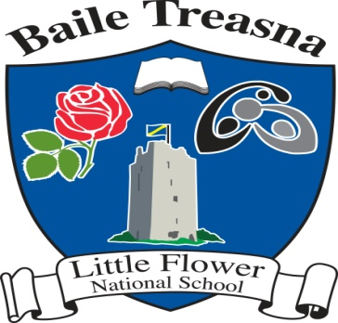

**Ballytarsna N.S.**

**ANNUAL ADMISSION NOTICE**

**In respect of admissions to the 2025/2026 school year**

**Admission Policy and Application Form**

|  |
| --- |
| A copy of the school’s Admission Policy and the Application form for Admission for the 2025/2026 school year is available as follows:  On request: By emailing [littleflowerns@gmail.com](mailto:littleflowerns@gmail.com) or phoning the school office at 0504 41323. |

**PART 1 – Admissions to the 2025/2026 school year**

**Application and Decision Dates for admission to 2025/2026 school year**

The following are the dates applicable for admission to Junior Infants

|  |  |
| --- | --- |
| The school will commence accepting applications for admission on | 10/02/2025 |
| The school shall cease accepting applications for admission on  (There must be a minimum period of 3 weeks between this date and the commencement date for accepting applications for admission) | 28/02/2025 |
| The date by which applicants will be notified of the decision on their application is  (This date must be within 3 weeks of the closing date for receipt of application or within 3 weeks of the application date for late applications) | 14/03/2025 |
| The period within which applicants must confirm acceptance of an offer of admission is | Within two weeks of offer. |

*Failure to accept an offer within the prescribed period above may result in the offer being withdrawn

Note: the school will consider and issue decisions on late applications in accordance with the school’s admission policy.

|  |  |
| --- | --- |
| Number of places being made available in 2025/2026 school year The number of places being made available in Junior Infants is | 15 |